Practical 4: Singly Linked List: Dynamic Insertion, Deletion, and Traversal
Practical Aim
To implement core singly linked list operations and develop the ability to manipulate dynamic sequences through real-world problem scenarios.
Problem 1
A hospital manages a queue of patient tokens. New critical patients must be added to the front, routine patients are added to the end, and occasionally a patient with a priority number must be inserted at a specific position in the queue. Given a sequence of such operations, implement all three insertion types and print the final queue after each operation.Describe how your insertion at a specific position works. What does your solution do if the position given is greater than the current length of the queue? Is that handled explicitly or does it cause an error?
SOLUTION:
https://github.com/prathameshpandir-dev/DSA-Batch-B-SHP/tree/main/practical-4
OUTPUT:
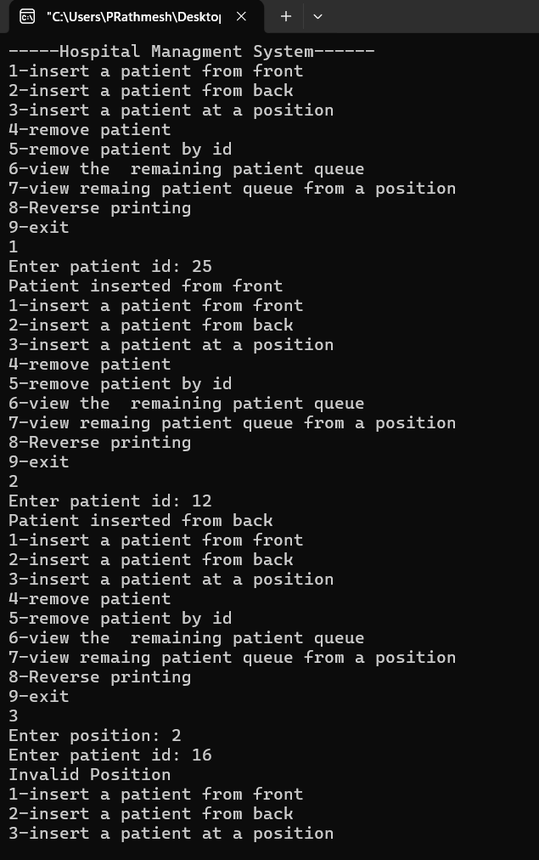

PROBLEM FACED:
The main difficulty was correctly connecting the new node at the required position and handling invalid positions.
CONCLUSION:
The different insertion operations in a singly linked list were successfully implemented. New nodes can be added at the front, end, and a specific valid position in the list.

Problem 2
The hospital also needs to remove a patient token from the queue when a patient leaves, print all remaining tokens from last to first for an end-of-day audit, and display the full queue from front to back at any point. Implement deletion by value, reverse printing, and forward traversal on the same queue from Problem 4.1a. Describe how your reverse printing works. Does it use any extra storage, or does it work purely by following the links? Can you think of another way to reverse-print without modifying the original queue?
SOLUTION:
https://github.com/prathameshpandir-dev/DSA-Batch-B-SHP/tree/main/practical-4
OUTPUT:
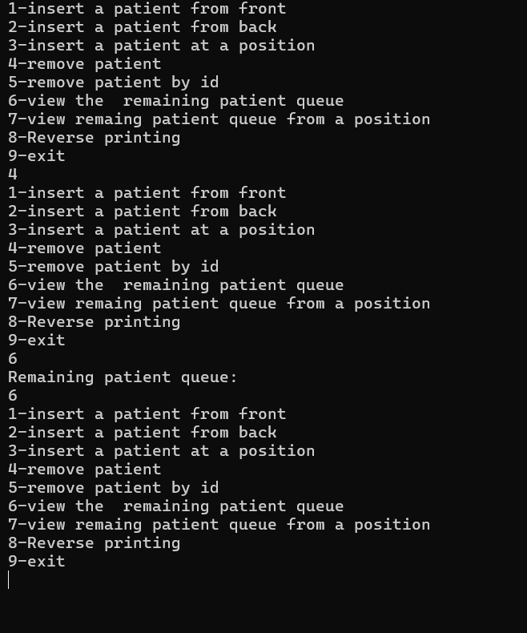

PROBLEM FACED:
The main difficulty was deleting a node safely and printing the list in reverse without changing the original list.
CONCLUSION:
Deletion, forward traversal, and reverse printing operations were successfully implemented. The linked list can be modified by deleting a node and displayed in both forward and reverse order.

Key questions

1. Problem 1
Answer: It should report an invalid position because silently inserting at the end may cause unexpected results. This assumes the caller should provide a valid position.

2. Problem 2
Answer: The head pointer is changed to null. Unlike middle-node deletion, there is no previous node whose next pointer needs to be updated.

